

VENICE FELLOWSHIP PROGRAMME APPLICATION FORM
BRITISH PAVILION
60th International Art Exhibition, la Biennale de Venezia
Location: Giardini, Venice - Italy, from 20 April to 24 November 2024
(pre-opening on 17, 18 and 19 April)

To complete this form please download it directly to your device. Once you have completed it, please submit it directly to your Partner organisation / contact.
To download the document, tick on ‘File’ (top left) > Download > Microsoft Word.

The British Council does not accept applications directly but rather works with and through our partner organisations across the UK.

SECTION ONE: GENERAL INFORMATION
Please note that questions marked with an * are mandatory.
Full Name:*
Pronouns:
Nationality:*
Address:*
Town/city [in UK]:*
Direct phone number:*
Email address:*
Please provide details here of any health conditions we need to be aware of:*
Name of the Institution/Organisation you are connected to/enrolled with:*

Name of course or programme you are enrolled on (if relevant):

Please confirm that by indicating/submitting the application form you are aware you will need to travel and live for a full month in Venice.* | Yes / No
Please confirm that by indicating/submitting the application form you are aware you will need to arrange/book your own travel and accommodation. Costs for covering these are part of your grant.* | Yes / No
Self-assessment of Socio-Economic Status: Compared to people in general, would you describe yourself as coming from any underrepresented groups in the creative sector, including those from the following: global ethnic majority, disabled, LGBTQIA+, and those facing social barriers to accessing the arts, creative industries, and other economic opportunities?  (Please note that the information you supply here will not inform any decision regarding your application as will only help for the purposes of improving inclusiveness and diversity through informed future programme planning) | Yes / No / Prefer not to say  Add a comment if you wish:
Confirm you have completed our  Equality and Monitoring Form survey here? | Yes / No

SECTION TWO: APPLICATION FORM GUIDELINES

Before completing further sections, please read our Fellowship Application Guideline here.

Please note that all applications (written, audio or video) should include the “SECTION ONE: General Information” above in writing only. Please remember to complete the above information even if you are applying via audio/video format.

Also, please remember to indicate your three preferred traveling months at the end of this form.

Video/Audio Application Format:

We welcome applications in both paper (written) or audio/video format. Feel free to use the method that is most comfortable for you.

If you are answering in video (audio and image) or just audio format, please use the below guidelines:

- A recorded application should not be overly produced. This is not an opportunity to demonstrate your skills in production, but to clearly communicate your skills/experience, project idea and interest in this opportunity in an accessible format.

- Please ensure your recording is no more than 8-10 minutes long, which is the equivalent to the word limit for written applications.

- You may link to a third-party platform such as Google Drive, Soundcloud, Vimeo or Dropbox. Please provide together with the link the password details, in case the link is password protected.

- Your recorded application should answer all the questions set out below in the written form. Please ensure you respond to these prompts clearly, and structure the content in relation to them, using the following timing guide:

250 words: 1-2 minutes
150 words: 30 seconds - 1 minute

Please add here the link to the video/audio, if this is your preferable method of application for the 2024 Venice Fellowship Programme:

SECTION THREE: MOTIVATION AND VISION

This section will help us understand why you are applying for the 2024 Venice Fellowship Programme so we can get to know you more, know what has inspired you, what you are proposing as a project/research idea, why it’s important to you, and how it connects to the programme values, ways of working and themes.

Please share with us anything you would like us to know about yourself, including, for example, your passions, hobbies, and/or interests. (Max words: 150)*

Please share with us a statement explaining what has intrigued or motivated you the most about our Programme. (Max words: 150)*

Project or Research idea: Please describe the idea that you would like to develop while in Venice for a full month period, and also, how you are planning to share it with your peers when you are back in the UK after the Fellowship.
Please remember that this must be aligned with the 2024 Exhibition of John Akomfrah’s work, our Programme eligibility and requirements, values and themes outlined in our Fellowship Application Guideline. (Max words: 250)*

SECTION FOUR: EXHIBITION AMBASSADOR

The second major component of the Venice Fellowship Programme is being an Exhibition Ambassador, which requires invigilating the British Pavilion, engaging with the public and being the public face of the British Council and its commission. This section will help us understand what experience you might already have and what your learning/skills development aims are.

Please describe here any challenges you think you might face inside the British Pavilion when acting as an Exhibition Ambassador. What are your suggested approaches to overcome them?
(Max words: 250)*

Please include here any relevant experience and/or skills you have, or what you would like to learn and develop when acting as an Exhibition Ambassador at the British Pavilion. (Max words: 250)*

Please state, in order of preference, three preferable traveling months in which you wish to undertake your fellowship in Venice (please note that you will need to be available during the full month as travel dates may vary according to the group allocations).*

1st choice:
2nd choice:
3rd choice:

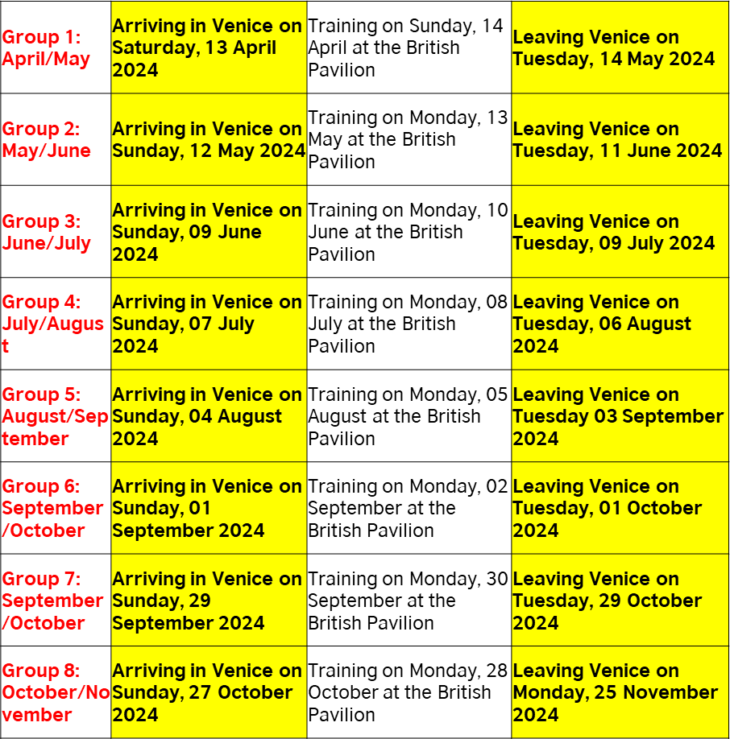

HOW TO APPLY:
To apply for a Fellowship position please send this completed form to your Institution/Organisation partnering with the British Council for the 2024 Venice Fellowship Programme. Please also complete our Equality and Monitoring Form survey here.

Deadline: 4 September - 8 November 2023
(Please note that the Partner Institution/Organisation is responsible for deciding the final and specific deadline date for application, but they must keep the application call open for a minimum of 48 days).

Many thanks for your interest and care in applying.
We are grateful for the time you have taken to apply. 😊

SECTION FIVE: PARTNER TO COMPLETE ONLY

If you are shortlisting this candidate for the British Council to be considered, please provide a short statement/reference below explaining your reasoning and the support you intend to provide this candidate while in Venice and back in the UK.
(Max words: 300)

Name:
Email:
Position:
Date:

